MINI PROJECT REPORT

ON

GAME OF PONG

MINI PROJECT LAB (KCS-354)

Submitted by-
Mukul Nag
Roll Number.1900970130067

Under the supervision of
Mr. Ranjit Kumar
Dr. Sandeep Saxena



Department of Information Technology
Galgotias College of Engineering and Technology
Greater Noida
December 2020

ACKNOWLEDGEMENT

I want to give special thanks to our Mini Project coordinator Mr. Ranjit Kumar and Dr. Sandeep Saxena for the timely advice and valuable guidance during designing and implementation of this project work.

I also want to express my sincere thanks and gratitude to Dr. Sanjeev Kumar Singh, Head of Department (HOD), for providing me with the facilities and for all the encouragement and support.

Finally, I express my sincere thanks to all staff members in the department of Information Technology branch for all the support and cooperation

Mukul Nag
(1900970130067)
3rd semester

Content

Sr. No. | Title | Page No. | Remarks
1. | Introduction | 4
2. | Features & Applications | 6
3. | Design | 7
 | - ER Diagram &Database flow chart (DFD) | 7
 | b) Database Design | 7
4. | Implementation | 8
5. | Snapshots & Results | 15
6. | Conclusion & Future work | 16
7. | References | 17
Introduction

GAME OF PONG

Video games are very popular electronic devices, which was invented in 1980s.It is a most selling device in past years. Now it is turned to machines which of high cost. In my project i implementing a old ping pong game in a 8x8 led matrix.
The user can play this game with the joystick same as in conventional videogames. The circuit consist of 4 section, first section is the pong board with 8x8 led matrix and 2 8led strip for pad section. A decoding section to decode entire 8x8 led matrix. The controlling section is done by 2 controllers namely atmel Atmega8. The function of 1st microcontroller is that, it is dedicated to game purpose only. The 2nd controller controllers entire function of gaming console. It controls the game and it display the score, level and life. The 4th section is display section which is for displaying score, life and level. It is done through an LCD.

This game project will be an homage to the classic Pong. In the original version, “paddles” vertically moving paddles controlled by two players hit a small pip (the ball) left and right. The ball would bounce off the top and bottom of the display
region. If the ball passed a player's paddle, a point would be added to the opponent's score. First to 11 won the game. The player winning the point would also win the serve, which meant that the ball would appear in front of that player's paddle and move toward the opponent’s side of the display. The angle of deflection of the ball from the paddle could be controlled by the speed at which the paddle was moving when it hit the ball. The speed of the ball slowly increased during a volley, but would return to the initial slower speed at the beginning of the next server. Sounds included a blip for the paddle striking the ball, a sound for a missed return and an end of game sound.

For this project, Python language and simplegui are used.

Features & Applications

- game loop
- game graphical display with sounds
- user interaction through the keyboard
- at least one animated object
- collision detection for fixed and moving objects
- score keeping
- management of game start (restart) and game completion

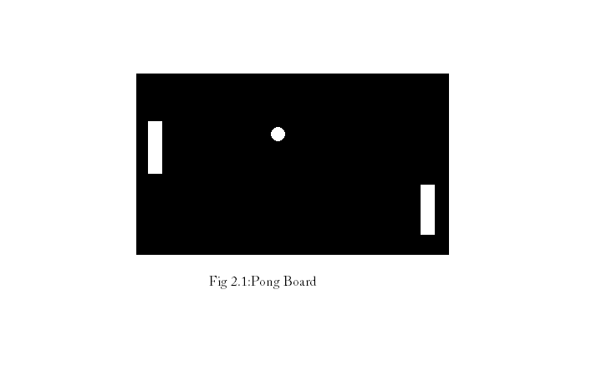

Design & flow chart

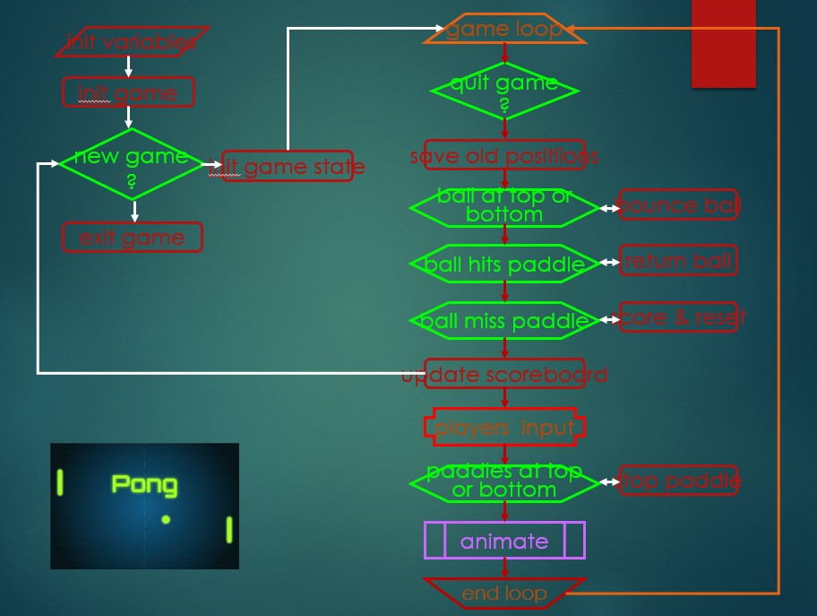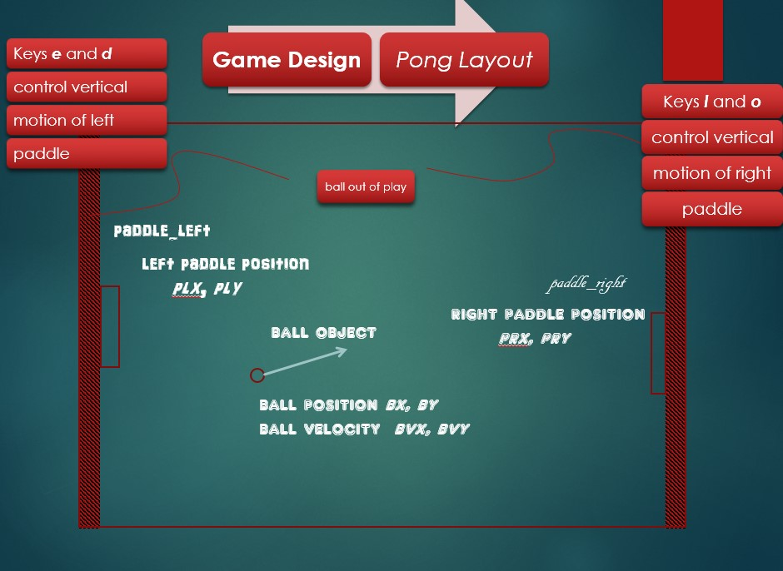
Implementation

The game of pong is made using python and simplegui library .

Following are the hardware requirements for this project:

- Minimum CPU: Platinum III or equivalent. Recommended CPU: intel core i3 with 6th generation or equivalent.
- CPU speed of at least 1 Giga Hertz.
- Minimum RAM: 256MB. Recommended RAM: 4GB.
- Operating System: Windows XP. Recommended: Windows 8.1 or higher.
- Low end graphics for visuals of at least 64MB.
- Disk Space: 2GB is recommended.

Visual Studio Code IDE is used for designing GUI and application .
simplegui - Simplified GUI generation using Tkinter

The simplegui file which is added to the libraries of python project, makes it possible to view any changes in GUI.
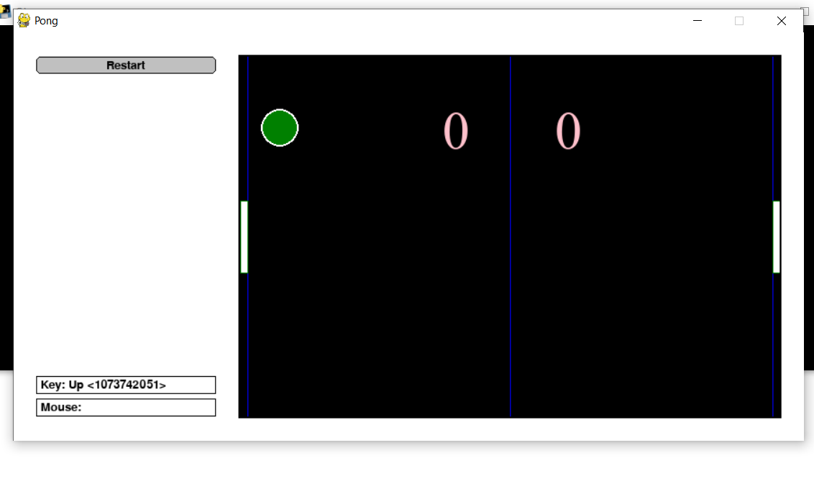

CODING

- Importing
try:
import simplegui
except ImportError:
import SimpleGUICS2Pygame.simpleguics2pygame as simplegui
# Implementation of classic arcade game Pong

import random

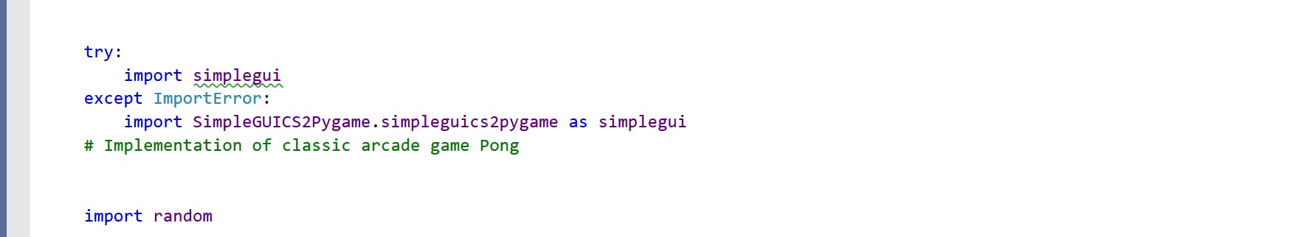

- Libraries Used

  - To handle various exceptions and GUI simplegui
  - To provide randomness random.

- initialize globals - pos and vel encode vertical info for paddles

width = 600
half_width = width / 2
height = 400
half_height = height / 2
ball_radius = 20
pad_width = 8
pad_height = 80
LEFT = False
RIGHT = True

#paddles
paddle1_pos = height / 2.5
paddle2_pos = height / 2.5
paddle1_vel = 0
paddle2_vel = 0
paddle_vel = 5

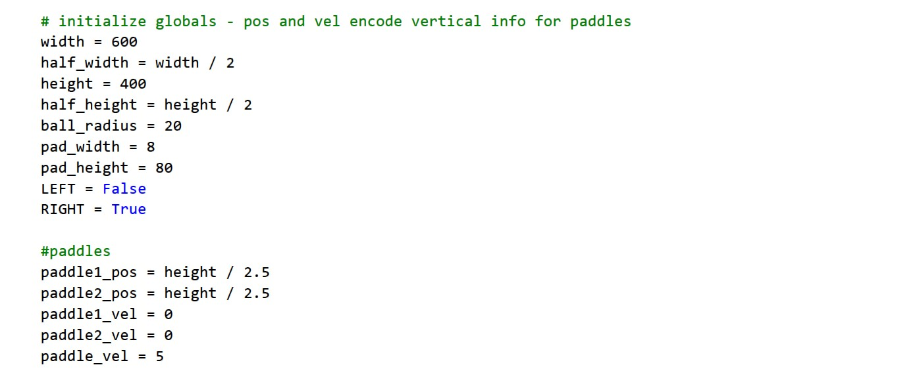

- If direction is RIGHT, the ball's velocity is upper right, else upper left
# if direction is RIGHT, the ball's velocity is upper right, else upper left
def spawn_ball(direction):
global ball_pos, ball_vel # these are vectors stored as lists
ball_pos = [half_width, half_height]
ball_vel[0] = -random.randrange(120,240) / 100
if direction == True:
ball_vel[0] *= -1
ball_vel[1] = -random.randrange(60, 180) / 100

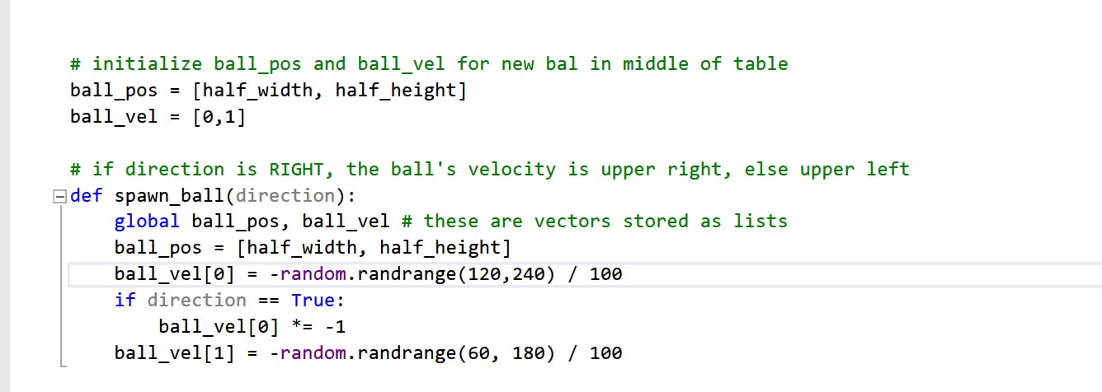

- define event handlers
def new_game():
global paddle1_pos, paddle2_pos # these are numbers
global score1, score2 # these are ints
score1 = 0
score2 = 0
spawn_ball(0)
paddle1_pos = height / 2.5
paddle2_pos = height / 2.5

def draw(c):
global score1, score2, paddle1_pos, paddle2_pos, ball_pos, ball_vel
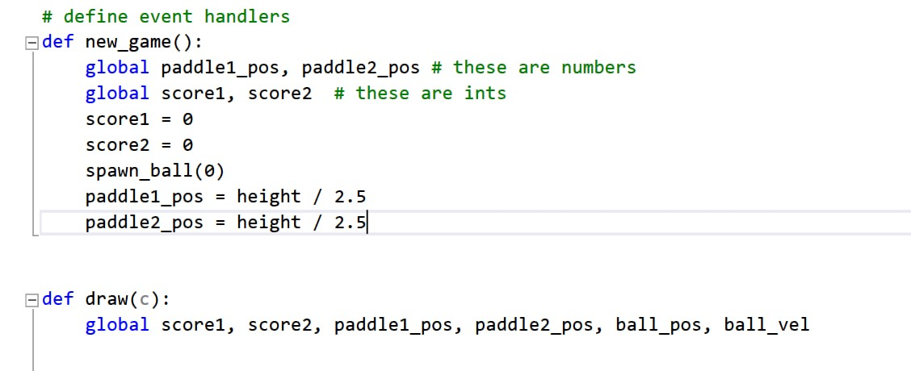
- Update ball

# update ball
ball_pos[0] += ball_vel[0]
ball_pos[1] += ball_vel[1]

if ball_pos[0] <= (ball_radius + pad_width) or ball_pos[0] >= (width - pad_width - ball_radius):
ball_vel[0] *= -1

if (ball_pos[0] > half_width):
if (ball_pos[1] < paddle2_pos or ball_pos[1] > paddle2_pos + pad_height):
score1 += 1
spawn_ball(LEFT)
else: ball_vel[0] += .1 * ball_vel[0]

if (ball_pos[0] < half_width):
if (ball_pos[1] < paddle1_pos or ball_pos[1] > paddle1_pos + pad_height ):
score2 += 1
spawn_ball(RIGHT)
else: ball_vel[0] += .1 * ball_vel[0]

if ball_pos[1] <= ball_radius or ball_pos[1] >= (height - ball_radius):
ball_vel[1] *= -1
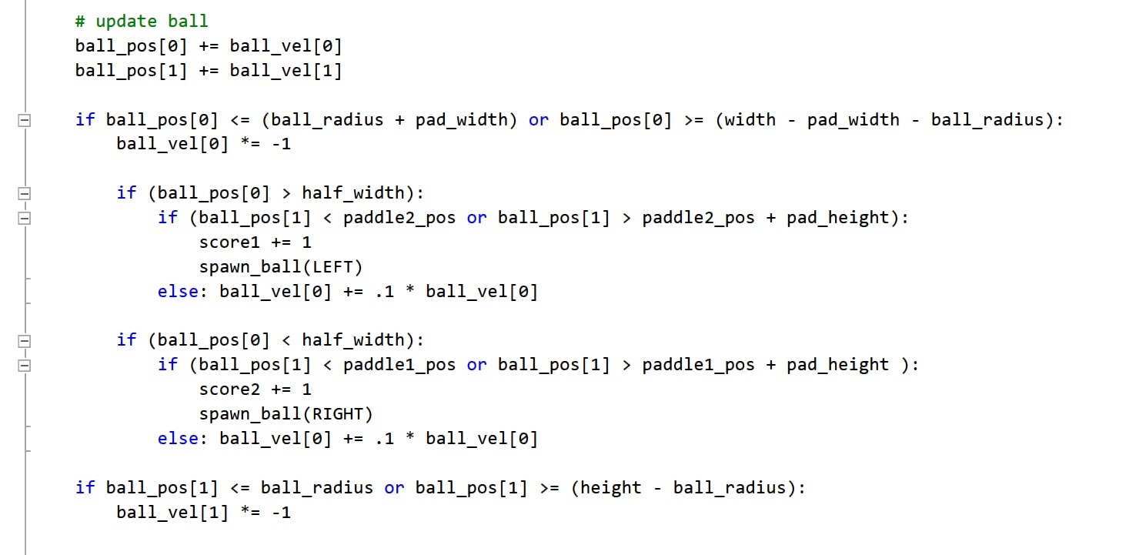
- Draw ball

# draw ball
c.draw_circle(ball_pos, ball_radius, 2, "White", "Green")

# update paddle's vertical position, keep paddle on the screen
global paddle1_vel, paddle2_vel

if (paddle1_pos <= height - pad_height and paddle1_vel > 0) or (paddle1_pos >= 0 and paddle1_vel < 0) :
paddle1_pos += paddle1_vel
elif (paddle2_pos <= height - pad_height and paddle2_vel > 0) or (paddle2_pos >= 0 and paddle2_vel < 0) :
paddle2_pos += paddle2_vel
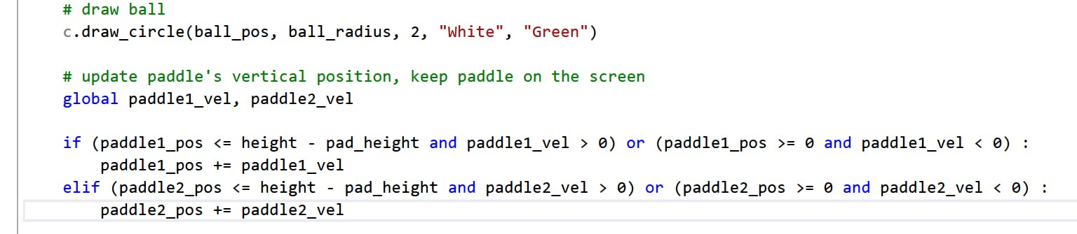

- Draw paddles

# draw paddles
c.draw_polygon([[0, paddle1_pos], [pad_width, paddle1_pos],[pad_width, (paddle1_pos) + pad_height ],[0, (paddle1_pos) + pad_height]],1, "green", "white")
c.draw_polygon([[width, paddle2_pos], [width - pad_width, paddle2_pos], [width - pad_width, paddle2_pos + pad_height], [width, paddle2_pos + pad_height]],1, "green", "white")
# draw scores
c.draw_text(str(score1), [225, 100], 60, "pink")
c.draw_text(str(score2), [350, 100], 60, "pink")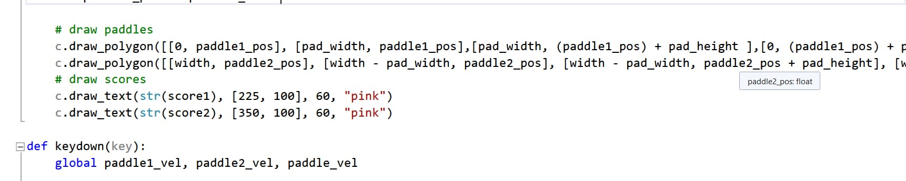
- Score keeping

#player1
if key == simplegui.KEY_MAP["w"]:
paddle1_vel = 0
elif key == simplegui.KEY_MAP["s"]:
paddle1_vel = 0

#player2
if key == simplegui.KEY_MAP["down"]:
paddle2_vel = 0
elif key == simplegui.KEY_MAP["up"]:
paddle2_vel = 0
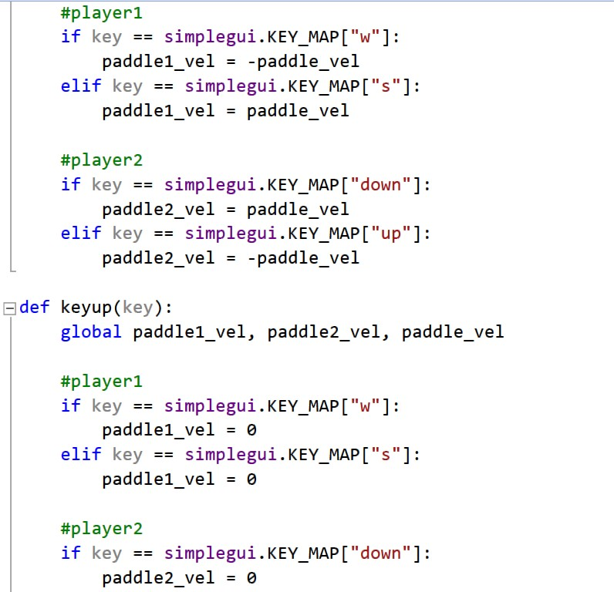

- Final function

# create frame
frame = simplegui.create_frame("Pong_by_mukul", width, height)
frame.set_draw_handler(draw)
frame.set_keydown_handler(keydown)
frame.set_keyup_handler(keyup)
frame.add_button("Restart", new_game, 200)

# start frame
new_game()
frame.start()
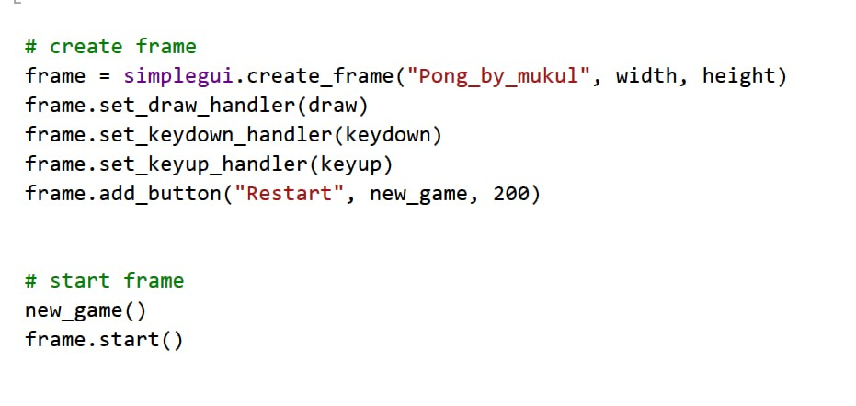

Snapshots & Result

The application run successfully of which certain outputs are as:

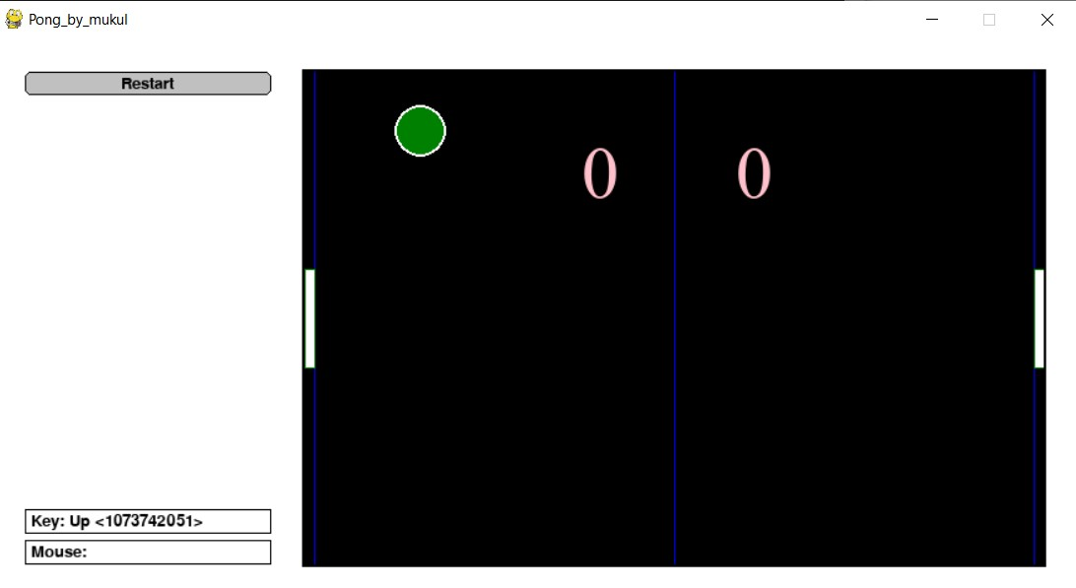

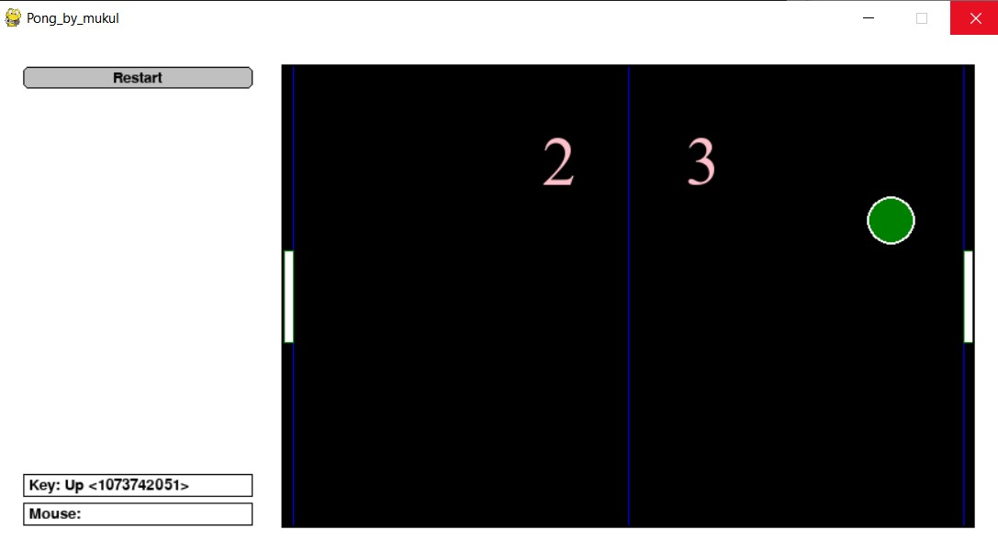

Conclusion and Future Work

It is a basic version of the application. It can be used to play the game. In addition, an exe can be transferred and can be run on any pc.
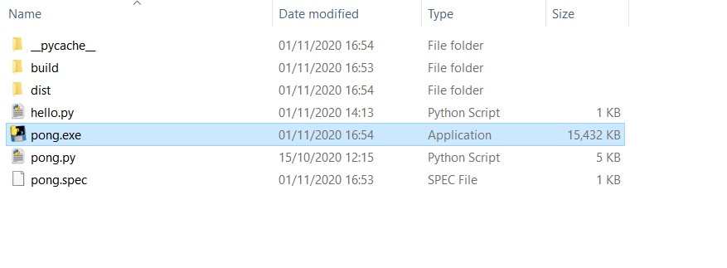

References

My deep gratitude also goes to Python manpages online reference material, which is available for free and YouTube videos explaining the concepts. Google Image Search obtains all credits of images used in each panels and each image credit goes to their respective owners.
- Python manpages -https://www.python.org/
- Codeskulpter -http://www.codeskulptor.org/docs.html#tabs-Python
- Symplegui2python https://bitbucket.org/OPiMedia

